Bidding for Lease Areas in Pacific Ocean:
Introducing Floating Offshore Wind Energy in California
This case is written from the lenses of Pacific Wind Co. management contemplating participating in the BOEM’s auction to lease five parcels in the Pacific Ocean by California’s coast. This case takes place a week before the final auction on December 6th, 2022. The main questions are (a) whether to participate in the auction, and (b) if so, what would be a reasonable bid range for the parcel you select? Your team must determine the “wind harvesting value” for your parcel and recommend how Pacific Wind Co. should bid in the upcoming auction.
- Offshore Wind Market

The global offshore wind market is rapidly expanding as nations worldwide prioritize cleaner and more sustainable energy sources. In 2021, numerous countries set ambitious offshore wind targets, with the European Union aiming for 60 GW by 2030. Europe leads this growth, with the United Kingdom, Germany, Denmark, and the Netherlands at the forefront, thanks to their favorable wind conditions, cutting-edge technology, and supportive government policies. Meanwhile, the Asia-Pacific region is also emerging as a key player, with significant investments in offshore wind infrastructure from countries like China, Taiwan, South Korea, and Japan.
While still in its early stages compared to global counterparts, the U.S. offshore wind industry is set for substantial growth. In 2021, the Biden administration set a goal of 30 GW of offshore wind capacity by 2030. Development efforts are concentrated on the East Coast, where favorable wind conditions, proximity to major population centers, shallow water depths, and supportive state policies create ideal conditions. States like Massachusetts, Virginia, New York, New Jersey, and North Carolina have already leased federal waters for offshore wind projects and awarded contracts for large-scale developments.
The 2022 Inflation Reduction Act makes offshore wind projects eligible for the Investment Tax Credit (ITC), offering a tax credit of up to 30% of the project’s capital costs. Furthermore, projects that use domestically produced materials and components can receive an additional 10% bonus on top of the base ITC.
However, the industry faces several challenges, including regulatory hurdles, environmental concerns, and opposition from various stakeholders such as fishermen and local communities. Additionally, the West Coast, particularly California, has been slower to embrace offshore wind due to regulatory complexities, competing ocean uses, and deep-water depths. Due the steep drop-off of the Pacific Outer Continental Shelf, California projects require floating wind turbines, which consist of a wind turbine placed on a floating platform that is tethered to the sea floor.

- Floating Offshore Wind Market
Despite being relatively new, floating offshore wind technology is rapidly evolving and becoming more cost-effective. As the number of manufacturers, developers, and planned and commissioned projects increases globally, the industry is expected to mature significantly. Economies of scale in construction and manufacturing, as well as larger turbine sizes, are anticipated to drive down the cost of electricity produced by FOSW, especially with the advent of new commercial-scale projects.
The FOSW industry has a short but notable track record. The first demonstration project, featuring a single turbine, was installed in Norway in 2009 (2.3 MW). The first commercial-scale project, Hywind Scotland, began production in 2017 (30 MW). Subsequent projects include Windfloat Atlantic (2020) and Kincardine (2021), generating 30 MW and 50 MW, respectively. To date, approximately 123 MW of floating wind projects have been installed, primarily in Europe.
The growth of FOSW projects is expected to continue as many countries set ambitious long-term goals for this technology. For instance, France plans to achieve 20 GW, and Scotland aims for 17 GW in the next two decades. In Asia, countries like South Korea, Japan, China, Taiwan, and the Philippines are also planning large projects. In the United States, the Biden administration has announced a target of 15 GW by 2035, including the Pacific lease sale, which encompasses an area with the potential for nearly 5 GW of power generation. By 2040, FOSW is projected to account for more than 20% of all globally installed offshore wind projects.
- Floating Offshore Wind Technology
Currently, FOSW turbines are identical to those used in fixed-bottom offshore wind projects, with the primary difference being the foundation. There are four main types of FOSW foundations: Spar, Tension Leg Platform, Semi-Submersible, and Barge. These foundations can be made from either concrete or steel, depending on factors such as site conditions, project scale, the technical capacity of operators and contractors, and local manufacturing, construction, and supply chain capabilities. Additionally, the availability of a skilled labor force plays a crucial role. Among these, the semi-submersible foundation is the most popular due to its suitability for rocky and sandy soils, as well as its ability to be reused and repurposed.

One significant advantage of FOSW is the ability to construct the wind turbine and its foundation at a port with specialized assembly and construction facilities, rather than at sea. This allows the FOSW turbine and its foundation to be assembled in a protected wind port and then towed to their final site, requiring simpler vessels. Compared to fixed-bottom structures that need ocean installation, this method is less risky and potentially more cost-effective.

However, there are currently few ports in California that can meet the requirements for the importation, manufacturing, or assembly of FOSW turbines. Several ongoing studies have identified promising ports and potential sites for the assembly and delivery of offshore wind turbines. Nonetheless, building the necessary ports and infrastructure is costly and may take many years to become a reality.

- California Offshore Wind
California aims to achieve 100% renewable energy generation by 2045. To ensure a consistent supply of renewable power around the clock, the California Energy Commission (CEC) is planning for 10 GW of new offshore wind generation by 2045.
California's 840-mile coastline holds the potential for up to 200 GW of wind energy generation. On May 31st, 2022, the Bureau of Ocean Energy Management (BOEM) announced a proposed sale notice for Pacific Wind Lease Sale 1. Interested bidders were required to submit documentation proving their legal, financial, and technical qualifications to own and operate the lease by August 1st, 2022.
The first designated area is located 21 miles off the coast of Humboldt Bay in Northern California, and the second area is 19 miles off the coast of Morro Bay in Central California. These wind farm locations are strategically situated to harness maximum sea wind speeds while remaining close enough to nearby ports for logistical efficiency.
- United States and California Electricity Prices:
The United States electricity markets are characterized by a complex and diverse landscape, encompassing both regulated and deregulated regions. In regulated markets, utilities own and operate the entire electricity supply chain, from generation to distribution, with rates set by public utility commissions. Conversely, deregulated markets promote competition among electricity generators, with independent system operators (ISOs) and regional transmission organizations (RTOs) overseeing the grid and ensuring reliability. These competitive markets aim to foster innovation, improve efficiency, and lower costs through market-based pricing mechanisms.

California's electricity market is governed by the California Independent System Operator (CAISO). Electricity prices within CAISO are often among the highest in the nation due to factors such as grid mix, regulation, and weather. Wholesale prices typically hover around $60 per megawatt-hour (MWh) but can spike to $250 per MWh depending on the time of year, as illustrated in Figures 6, 7, and 8. As more renewables are integrated into the grid, market participants can expect increased price volatility in the future.

- Economics of Offshore Wind

- FOSW Revenue
Like most power plants, Floating Offshore Wind (FOSW) projects are expected to generate the majority of their revenue through power purchase agreements (PPAs). A PPA is a contract between an electricity generator and a buyer, such as a utility or corporation. The generator commits to producing and selling electricity to the buyer at a predetermined price over a specified period, ensuring revenue stability for the generator and a long-term electricity supply for the buyer. Current American offshore wind offtake agreements typically last between 20-25 years, with prices ranging from $42 to $118 per megawatt-hour (MWh) (see exhibits 5 and 6 in the appendix).

Due to the price stability provided by PPAs, maximizing power production is crucial for the development of renewable energy projects. Offshore wind has the advantage of higher and more consistent wind speeds compared to onshore sites, resulting in higher capacity factors. For the California parcels, capacity factors are projected to be close to 50%, while onshore projects in America average around 33%.

To calculate the power output for a wind project, multiply the capacity factor by the nameplate capacity and the time. For example, for a 990 MW project with a 50% capacity factor, the energy output would be calculated as follows:

- Costs of FOSW

Floating offshore wind (FOSW) is a capital-intensive technology where most of the investment is made upfront, and operating costs are relatively low. According to the National Renewable Energy Laboratory (NREL), 17.8% of the levelized cost of energy (LCOE) for offshore wind projects is attributed to operations and maintenance (O&M). In contrast, combined cycle and gas plants see 51% of their costs coming from O&M. This means that a larger portion of renewable power plants' cost structures is tied to upfront capital expenditures (CAPEX) and borrowing costs. Fossil fuel plants are less sensitive to changes in borrowing costs and CAPEX.

FOSW CAPEX includes costs related to the development phase, components, and installation processes, all of which are site-dependent (distance to shore and water depth), various financial expenses and insurance, and general management costs. Major components include turbines and substructures, mooring systems, and all electrical and connecting cables (submarine cabling, onshore and offshore substations). CAPEX also encompasses development expenditures (DEVEX), such as environmental surveys, permitting, project management, and development services. These costs are mostly incurred before the operation of the FOSW project and vary with the project's size.

Turbine costs consist of the rotor (blades, hub, etc.), nacelle (which houses the turbine components), and tower. The nacelle represents a significant portion of the turbine cost, followed by the rotor and tower. Since floating substructures are relatively new and have not been widely used in large-scale projects, obtaining accurate cost estimates is challenging. Similarly, estimates for mooring costs in deep waters are highly uncertain. Grid integration costs, including connection and inter-array cables, generally increase with distance to shore. Additionally, transportation and installation costs for semi-submersible foundations are expected to be lower than for other types of floaters and fixed-bottom structures. Our current California CAPEX estimates are detailed in Exhibits 1 and 2.

Operation and maintenance costs (OPEX) for FOSW projects are relatively lower compared to conventional power plants. The fixed portion of these costs includes replacement and repair of components, O&M workforce wages, and expenditures for equipment and port services. The variable component covers expenses associated with routine inspections and travel to turbines. OPEX is expected to decline for large projects due to economies of scale. However, since large-scale FOSW projects have not yet been developed, accurately estimating O&M costs is difficult. Our current California OPEX estimates are provided in Exhibits 1 and 2.

C. Financing Floating Offshore Wind Projects

As mentioned in the previous section, floating offshore wind (FOSW), like other renewable energy sources and fixed-bottom offshore wind, is capital-intensive: most of the investment is required upfront to build the infrastructure, which then has relatively low operating and maintenance costs. This implies that once operational, the primary cost is the repayment of the initial investment (through interest and principal on loans, or dividends to equity providers). Therefore, FOSW’s long-term cost base is (i) largely fixed from day one, and (ii) highly dependent on the cost of capital. Economically, this means that the single most significant driver of electricity costs for FOSW is the cost of capital. Lowering the cost of capital reduces the overall cost of spreading the initial investment over future production years. Debt is the cheapest form of capital, so raising more debt for a project and extending its maturity period makes the electricity cheaper.

This is where "project finance" or "non-recourse finance" becomes relevant. This type of debt is provided directly to a project and is repaid solely from the project's revenues, without guarantees from the project's owners. The cost of capital for a project-financed endeavor is the weighted average of the cost of equity (over the project's life) and the cost of debt (over the debt's duration), making it structurally lower than financing the project solely with equity, thus highly attractive for capital-intensive projects. Although the cost of equity for investors using non-recourse debt is slightly higher than for sponsors investing directly in projects, this is more than offset by the lower cost of non-recourse debt specifically provided to the project.

Given that lenders will only be repaid by the project's revenues, they will ensure that the project is operated efficiently for at least the duration of the debt maturity and generates enough revenue (i.e., sufficient production sold at a high enough price) to service the debt. To mitigate these risks, lenders require that the various tasks and commitments be allocated to the appropriate parties and contracted in sufficient detail to address most circumstances. This typically involves extensive involvement in the project's contractual setup and thorough "due diligence"—technical, legal, and other verifications by third-party experts of every aspect of the project (including permits, technology, schedule, budget, personnel, and market conditions).
D. Levelized Cost of Energy:
An essential concept in evaluating energy projects is the levelized cost of energy (LCOE)*. LCOE is a metric used to assess and compare different methods of energy production. It represents the average total cost of building and operating an energy-generating asset per unit of electricity generated over its assumed lifetime.

Alternatively, LCOE can be viewed as the average minimum price at which the electricity produced by the asset must be sold to cover the total production costs over its lifetime. Calculating LCOE is related to evaluating a project's net present value (NPV). Similar to using NPV, LCOE can help determine whether a project is a viable investment.

*Note: LCOEs of fossil fuel plants are not directly comparable to those of variable renewable energy (VRE) plants because VRE’s LCOEs do not account for costs associated with addressing intermittency. However, LCOE comparisons do support the current understanding that VRE-based electricity costs have fallen below those of fossil fuel-based electricity in recent years.

3. Auction Summary

The final auction is scheduled for December 6th, with a mock auction occurring the day before. Forty-three entities, including Pacific Wind Co., have been approved by the Bureau of Ocean Energy Management (BOEM) to participate. To join both the mock and final auctions, potential bidders had to submit a bid deposit of $5 million to BOEM.
The Bureau of Ocean Energy Management (BOEM), a division of the United States Department of the Interior, is responsible for managing the development of energy and mineral resources on the Outer Continental Shelf (OCS). Established in 2010, BOEM oversees the leasing, exploration, development, and production of both renewable and non-renewable energy resources in federal waters.
Auction rules stipulate that bidders can only bid for one Lease Area at a time. Bids are submitted in rounds, each starting with BOEM declaring an asking price for each Lease Area. The auction continues as long as there are at least two active bids for any Lease Area. Provisional winners are determined by the highest bid in the final round.
Winning bidders receive a one-year period for preliminary studies, five years for site assessment, and thirty-three years for operation. Leases can be renewed after thirty-three years, but renewal is not guaranteed. Additionally, bid winners are prohibited from drilling for oil or minerals on their ocean parcels.

Case Questions:
1. Will you participate in the auction? If yes, will you bid on Morro Bay or the Humboldt Wind Area?
2. How do you formulate your bidding strategy for the lease? What is your starting bid and what is your maximum bid?
3. Given the CAPEX, OPEX, and cash flows what is the NPV/IRR of the project?

4. What is the project’s financial sensitivity to electricity prices and interest rates? What are strategies to mitigate those risks?

5. As a developer, what litigation risks do you foresee when developing floating offshore wind projects in California?

6. How do social factors and community acceptance impact the financial viability of these projects, and what are your plans for mitigating these risks?

7. What are the risks in each phase (DEVEX, CAPEX, OPEX) of the project?

Appendix:
Figure 1: Annual Offshore Wind Installations

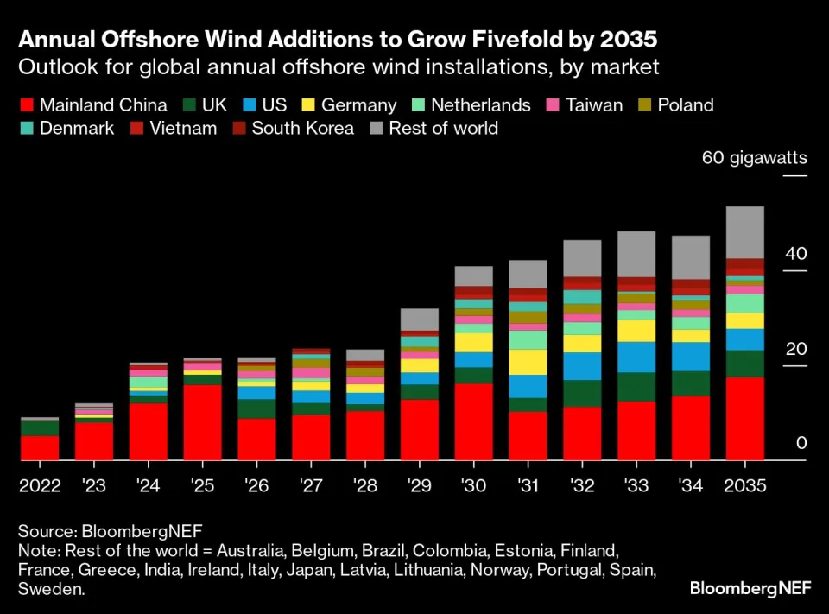
Source: https://www.bloomberg.com/news/features/2024-03-17/offshore-wind-s-next-big-problem-not-enough-ships?embedded-checkout=true

Figure 2: Auction Results

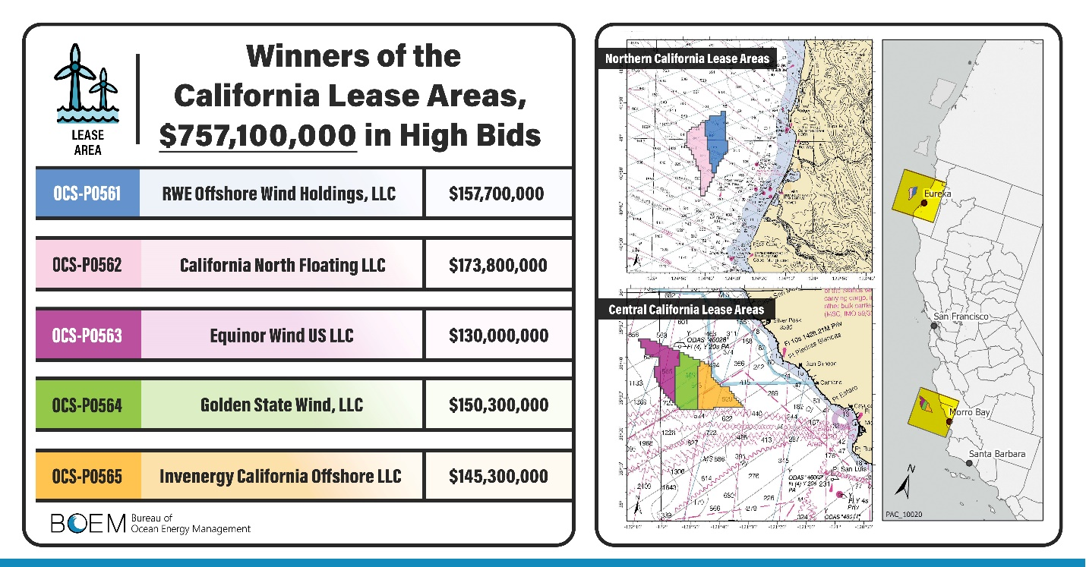

Source: https://www.boem.gov/renewable-energy/state-activities/california

Figure 3: Price per Acre

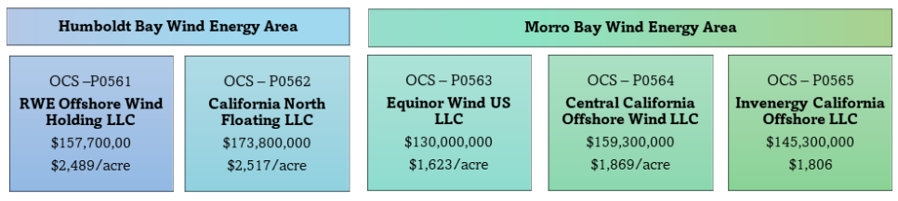

Source: https://owcltd.com/media/blog/the-case-of-california-757m-auction-closes-with-offshore-wind-winners/

Figure 4: Wind Energy Potential:

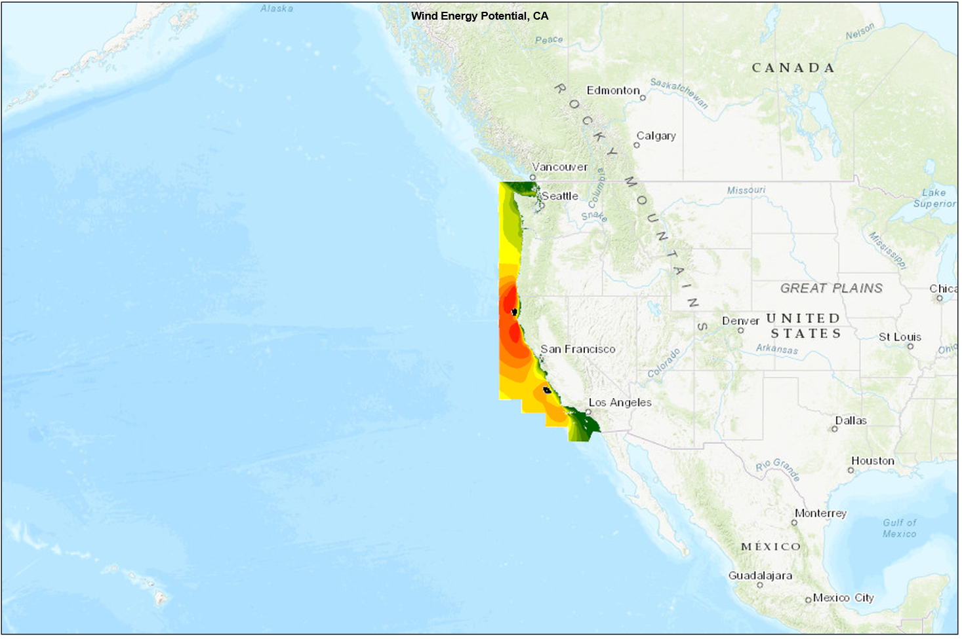

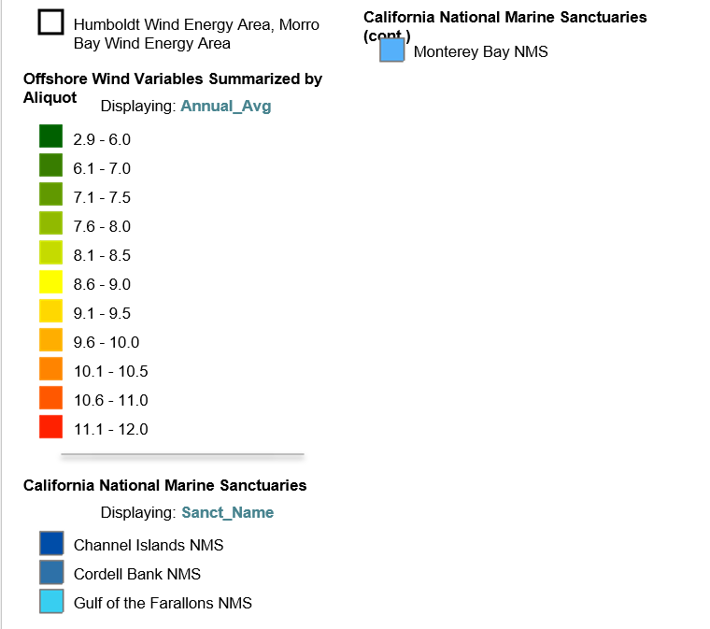

Figure 6: US Offshore Wind Pipeline
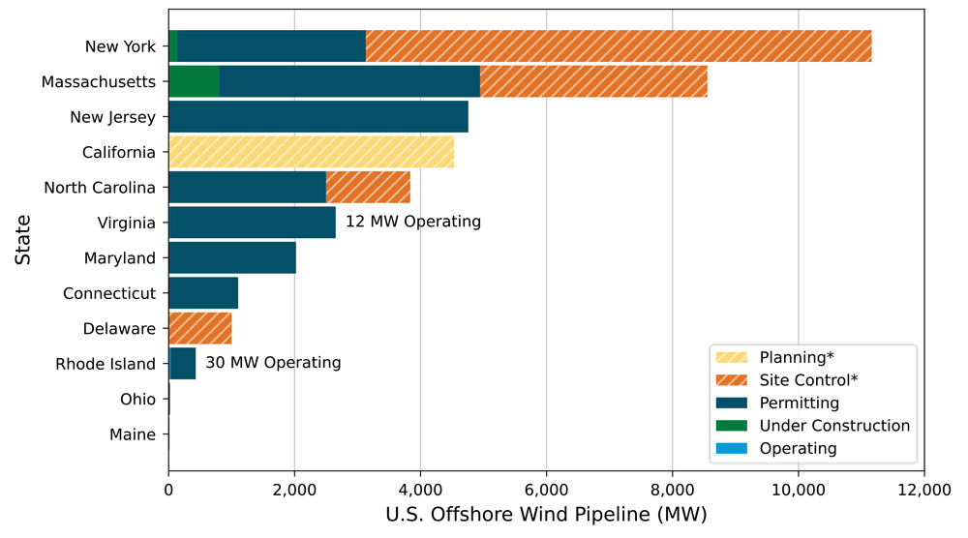

Source: Department of Energy's Offshore Wind Market Report, August 2023
Table 1: US Offshore Wind Auction Results
Year | State | State Offtake Policy | Lease Area | Bid Price ($) | Winner | Technology | Capacity (MW) | Area (KM^2) | Acres
2023 | TX | No | OCS- G 37334 | $5,600,000 | RWE | Fixed | 1,659 | 415 | 102,480
2022 | CA | No | OCS- P 0561 | $157,700,000 | RWE | Floating | 1,025 | 256 | 63,338
2022 | CA | No | OCS-P 0562 | $173,800,000 | CIP | Floating | 1,117 | 279 | 69,031
2022 | CA | No | OCS- P 0563 | $130,000,000 | Equinor | Floating | 1,296 | 324 | 80,062
2022 | CA | No | OCS-P 0564 | $150,300,000 | EDPR/Engie | Floating | 1,302 | 325 | 80,418
2022 | CA | No | OCS- P 0565 | $145,300,000 | Invenergy | Floating | 1,302 | 325 | 80,418
2022 | NY/NJ | Yes | OCS- A 0537 | $765,000,000 | EDPR/Engie | Fixed | 1,158 | 289 | 71,522
2022 | NY/NJ | Yes | OCS-A 0538 | $795,000,000 | Total Energies | Fixed | 1,365 | 341 | 84,332
2022 | NY/NJ | Yes | OCS-A 0539 | $1,100,000,000 | RWE/National Grid | Fixed | 2,039 | 510 | 125,964
2022 | NY/NJ | Yes | OCS-A 0541 | $780,000,000 | EDF/Shell | Fixed | 1,284 | 321 | 79,351
2022 | NY/NJ | Yes | OCS-A 0542 | $645,000,000 | Invenergy | Fixed | 1,352 | 340 | 83,976
2022 | NY/NJ | Yes | OCS-A 0544 | $285,000,000 | Avangrid | Fixed | 697 | 174 | 43,056
2022 | NC | No | OCS- A 0545 | $160,000,000 | TotalEnergies | Fixed | 889 | 223 | 54,937
2022 | NC | No | OCS-P 0546 | $155,000,000 | Duke Energy | Fixed | 893 | 222 | 55,154
2018 | MA* | No | OCS-A 0520 | $154,525,000 | Equinor/BP | Fixed | 2,430 | 521 | 128,811
2018 | MA* | No | OCS-A 0521 | $154,525,000 | Shell/EDPR/Engie | Fixed | 2,004 | 516 | 127,388
2018 | MA* | No | OCS-A 0522 | $154,639,500 | Avangrid | Fixed | 2,143 | 536 | 132,370
* Massachusetts bid prices are inflation adjusted to 2022 dollars
Source: Department of Energy's Offshore Wind Market Report, August 2023
Table 2: Global Floating Offshore Wind Pipeline
Pipeline Classification | United States | Other | Asia | Europe | Total
Operating | 0 | 0 | 11 | 113 | 123
Under Construction | 0 | 0 | 260 | 187 | 447
Financial Close | 0 | 0 | 0 | 0 | 0
Approved | 0 | 0 | 0 | 0 | 0
Permitting | 12 | 0 | 0 | 206 | 218
Site Control | 6,042 | 0 | 0 | 0 | 6,042
Planning | 144 | 13,750 | 21,261 | 60,544 | 95,699
Total Pipeline | 6,198 | 13,750 | 21,531 | 61,050 | 102,529
Source: Department of Energy's Offshore Wind Market Report, August 2023
Figure 7: Floating Offshore Wind Turbine Foundation Types

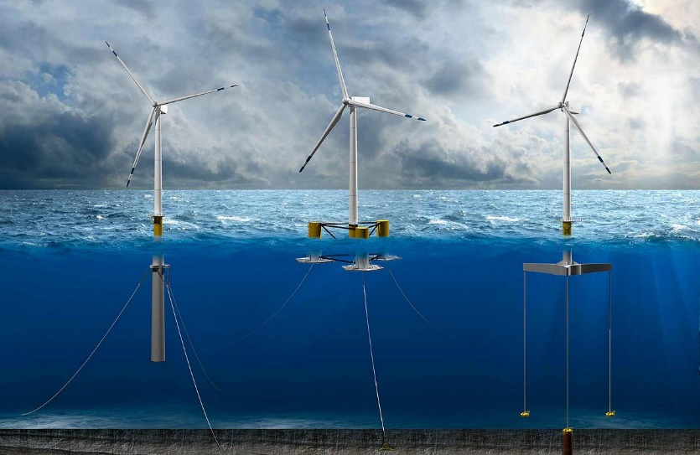
Source: https://www.nrel.gov/news/program/2020/nrel-floats-new-offshore-wind-cost-optimization-tool.html

Figure 8: California Offshore Wind Lease Areas
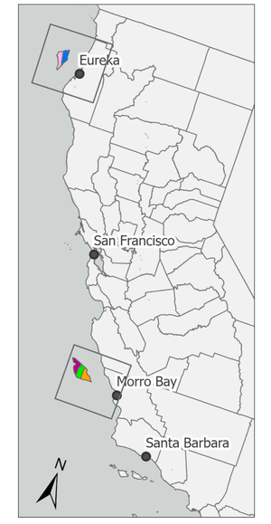
Source: https://www.boem.gov/renewable-energy/state-activities/california
Figure 9: US ISO and RTO Yearly Prices
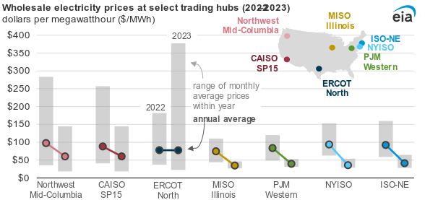Source: https://www.eia.gov/todayinenergy/detail.php?id=61445
Figure 10: CAISO Prices
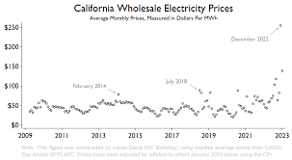
Source: https://energyathaas.wordpress.com/2023/02/21/a-very-expensive-winter/
Figure 11: US ISO and RTO Monthly Prices
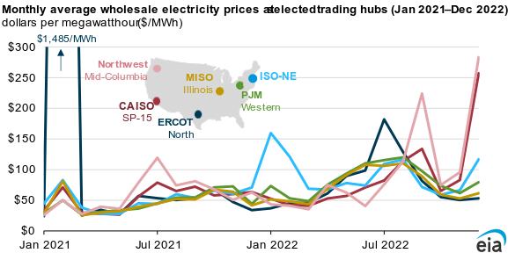
Source: https://www.eia.gov/electricity/issuestrends/
Figure 12: PPA Structure

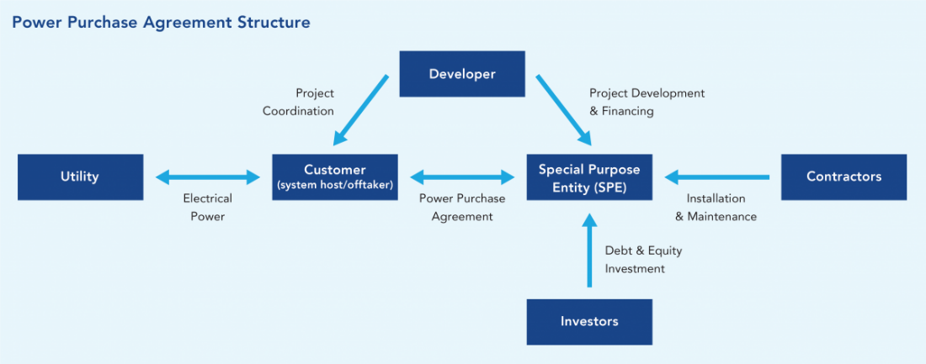
Source: https://betterbuildingssolutioncenter.energy.gov/financing-navigator/option/power-purchase-agreement#:~:text=A%20Power%20Purchase%20Agreement%20(PPA,output%20for%20a%20predetermined%20period.

Figure 13: LCOE by Phase for FOSW

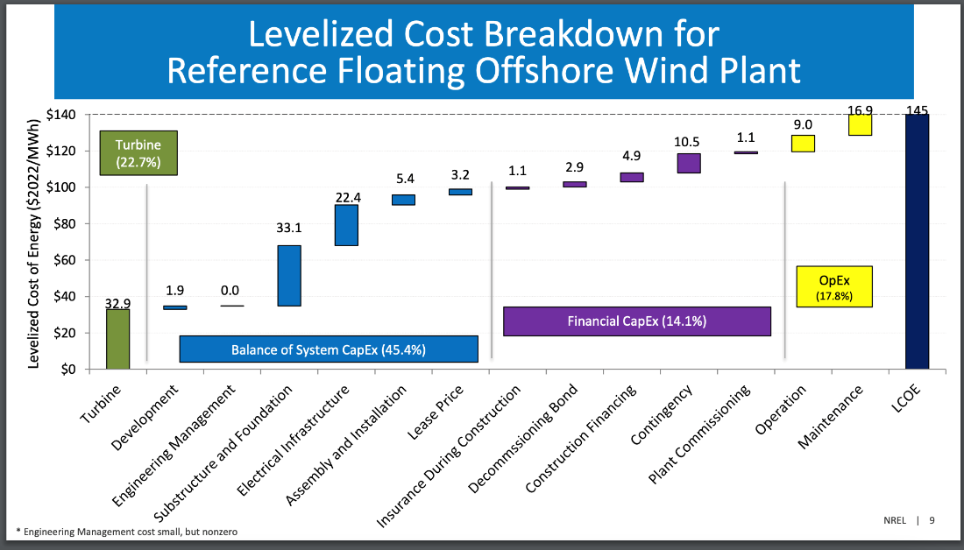
Source: https://www.nrel.gov/docs/fy24osti/88335.pdf

Figure 13: Offshore Wind Financing Example
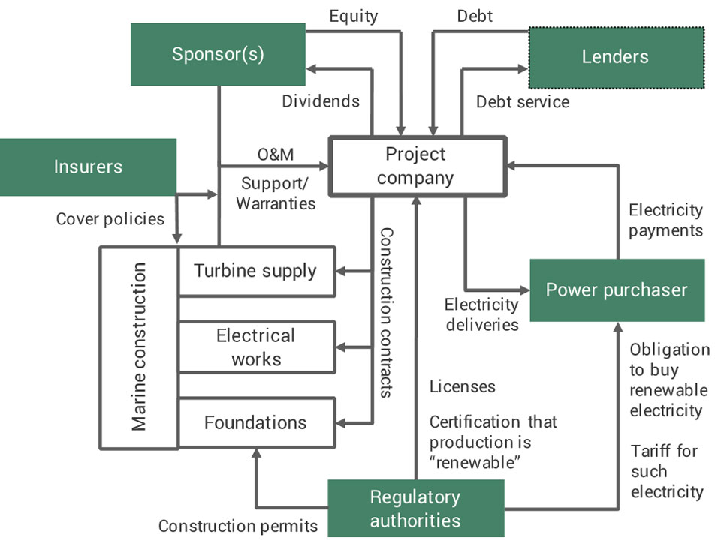
Source: https://wfo-global.org/wp-content/uploads/2022/09/WFO_FinancingOffshoreWind_2022.pdf
Figure 14: Timeline of Offshore Wind Financing
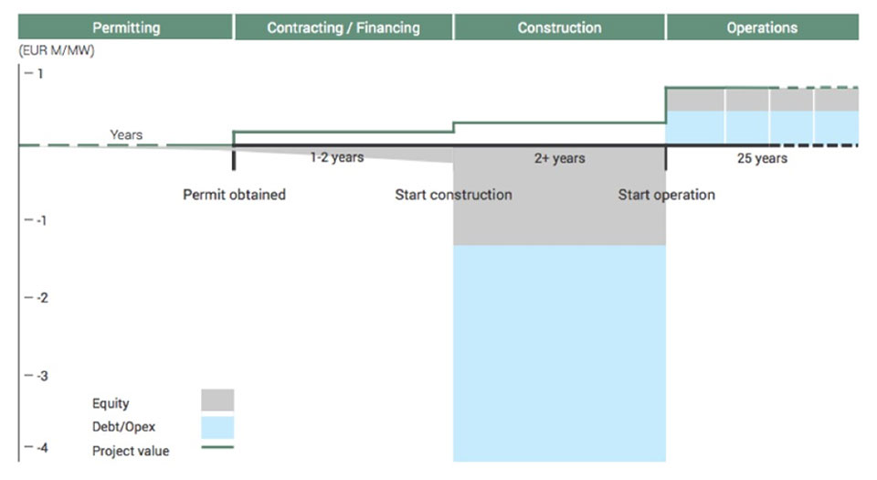
Source: https://wfo-global.org/wp-content/uploads/2022/09/WFO_FinancingOffshoreWind_2022.pdf

Figure 15: LCOE Calculation
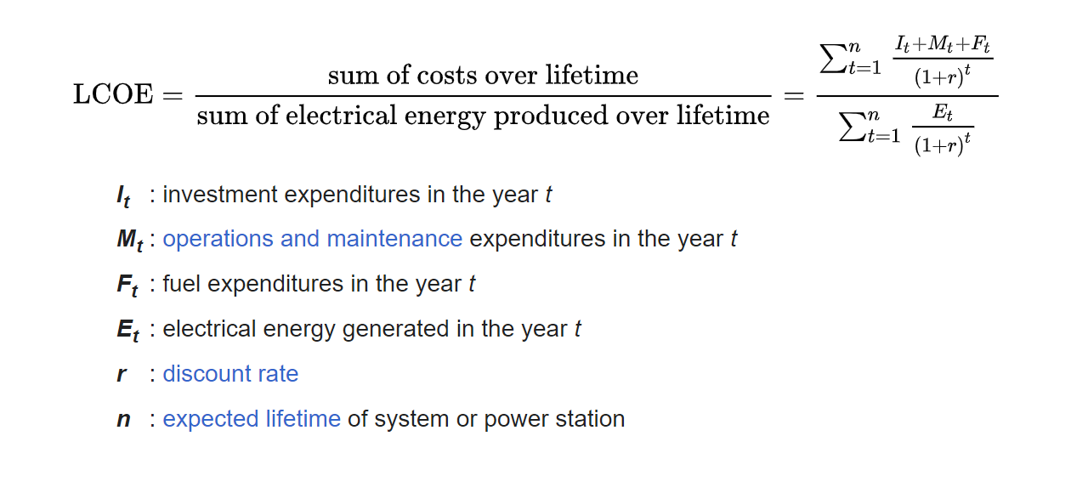
Source: https://www.ourworldofenergy.com/vignettes.php?type=electrical-power-generation&id=16

Exhibit 1: Morro Bay Assumptions
Project Assumptions | Inputs | Units
OCS-P 0563 Capacity | 1296 | MW
OCS-P 0564 & 0565 Capacity | 1302 | MW
Capacity Factor | 46.5% | %
CAPEX | $4,342.00 | $/kWh
OPEX | $123.00 | $/kWh

Exhibit 2: Humboldt Assumptions
Project Assumptions | Inputs | Units
OCS-P 0561 Capacity | 1025 | MW
OCS-P 0562 Capacity | 1117 | MW
Capacity Factor | 49.9% | %
CAPEX | $4,287.00 | $/kWh
OPEX | $118.00 | $/kWh

Exhibit 3: Financing Assumptions
Project Assumptions | Inputs | Units
O&M Escalation Rate | 2.25% | %
IRA Investment Tax Credit | 30% | %
IRA ITC Domestic Tax Adder | 10% | %
Debt % | 60% | %
Equity % | 40% | %
Economic Useful Life | 20 | years
MACRS Depreciation Schedule | 5 | years
Combined Tax Rate | 40% | %

Exhibit 4: US Lease Areas Technical Information
Units | m/s | meters | nautical miles | years
Lease Area | Wind Speed | depth (m) | Distance from shore | length of lease
Gulf of Mexico
OCS- G 37334 | 7.9 | 11.8 | 24.0 | 39
California | 9.9 | 934.8 | 20.0 | 33
Humboldt | 10.5 | 754.5 | 20.0 | 33
OCS- P 0561 | 10.3 | 723.0 | 20.0 | 33
OCS-P 0562 | 10.6 | 786.0 | 20.0 | 33
Morro Bay | 9.6 | 1055.0 | 20.0 | 33
OCS- P 0563 | 9.7 | 1126.0 | 20.0 | 33
OCS-P 0564 | 9.6 | 1051.0 | 20.0 | 33
OCS- P 0565 | 9.4 | 988.0 | 20.0 | 33
NY Bight | 8.7 | 43.3 | 31.3 | 33
OCS- A 0537 | 8.8 | 55.0 | 38.0 | 33
OCS-A 0538 | 8.6 | 44.0 | 36.0 | 33
OCS-A 0539 | 8.7 | 35.0 | 32.0 | 33
OCS-A 0541 | 8.7 | 41.0 | 27.0 | 33
OCS-A 0542 | 8.7 | 44.0 | 35.0 | 33
OCS-A 0544 | 8.6 | 41.0 | 20.0 | 33
Carolina | 7.9 | 30.0 | 20.0 | 33
OCS- A 0545 | 7.9 | 30.0 | 20.0 | 33
OCS-P 0546 | 7.9 | 30.0 | 20.0 | 33
Massachussets | 9.4 | 50.0 | 16.3 | 33
OCS-A 0520 | 9.3 | 51.0 | 17.0 | 33
OCS-A 0521 | 9.4 | 51.0 | 20.0 | 33
OCS-A 0522 | 9.4 | 48.0 | 12.0 | 33

Exhibit 5: Power Offtake Contracts for US Offshore Wind Energy Projects
Project | Year Awarded | Size (MW) | Duration (Years) | Offtake Type | Levelized Nominal Price ($/[MWh]) | Inflation-Adjusted Price (2023$/MWh)
SouthCoast Wind 1a | 2020 | 400 | 20 | PPA | $58.40 | $63.70
SouthCoast Wind 1a | 2020 | 404 | 20 | PPA | $58.40 | $63.70
New England Wind 1a | 2021 | 800 | 20 | PPA | $79.80 | $85.40
Empire Wind 2 | 2021 | 1,260 | 25 | NY OREC | $107.50 | $115.00
Beacon Wind 1 | 2021 | 1,230 | 25 | NY OREC | $118.00 | $126.30
Ocean Wind 2 | 2021 | 1,148 | 20 | NJ OREC | $42.30 | $45.30
Atlantic Shores Offshore Wind South Project 1 | 2021 | 1,510 | 20 | NJ OREC | $58.80 | $62.90
Skipjack 2 | 2021 | 846 | 20 | MD OREC | $71.60 | $76.60
Momentum Wind | 2021 | 809 | 20 | MD OREC | $54.17 | $57.90
SouthCoast Wind 1b | 2021 | 400 | 20 | PPA | $77.00 | $82.40
New England Wind 1b | 2021 | 1,232 | 20 | PPA | $72.00 | $77.00
CVOW (Commercial) | 2021 | 2,587 | 20 | Utility Owned | $87.00 | $93.10

Exhibit 5: Worldwide Power Offtake Contracts:
Commercial Operation Date | Project name | Country | Adjusted Price (2021USD/MWh)
2017 | Dudgeon Extension | United Kingdom | 221
2017 | Burbo Bank Extension | United Kingdom | 221
2019 | Walney Extension | United Kingdom | 221
2019 | Beatrice | United Kingdom | 172
2019 | Hornsea ONE | United Kingdom | 206
2019 | East Anglia ONE | United Kingdom | 177
2019 | Horns Rev 3 | Denmark | 115
2020 | Neart na Gaoithe | United Kingdom | 168
2020 | Vesterhav Nord & Syd | Denmark | 98
2020 | Borssele 1 and 2 | Netherlands | 114
2021 | Triton Knoll | United Kingdom | 144
2021 | Kriegers Flak | Denmark | 75
2022 | Hornsea 2 | United Kingdom | 111
2022 | Moray East | United Kingdom | 111
2022 | Hollandse Kust Zuid III & IV | Netherlands | 84
2022 | Vineyard Wind 1 | United States | 103
2023 | Borssele 3 & 4 | Netherlands | 92
2023 | Gode Wind 3 | Germany | 87
2023 | Vineyard Wind 2 | United States | 88
2023 | Revolution Wind | United States | 95
2023 | U.S. Wind | United States | 149
2023 | Skipjack | United States | 149
2024 | Borkum Riffgrund West 2 | Germany | 92
2024 | OWP West | Germany | 91
2024 | Borkum Riffgrund West 1 | Germany | 90
2024 | Ocean Wind | United States | 107
2024 | Empire Wind | United States | 100
2024 | Sunrise Wind | United States | 93
2024 | Doggerbank A | United Kingdom | 94
2025 | Gode Wind 4 | Germany | 130
2025 | He Dreiht | Germany | 94
2025 | Mayflower Wind | United States | 75
2025 | Doggerbank B | United Kingdom | 96
2026 | Skipjack 2 | United States | 115
2028 | Atlantic Shores Offshore Wind 1 | United States | 108

Exhibit 6: California Power Prices
Source | Time Period | ($/megawatt-hour [MWh])
LevelTen Energy CAISO Wind PPA Price Index | 2022 Q3 | $60.00
CAISO Wind Wholesale Market Value | 2022 | $76.00
FERC - CAISO Average Wholesale Electricity Price | 2023 | $63.92

Exhibit 7: Power Generation Technologies Cost of Capital Sensitivity
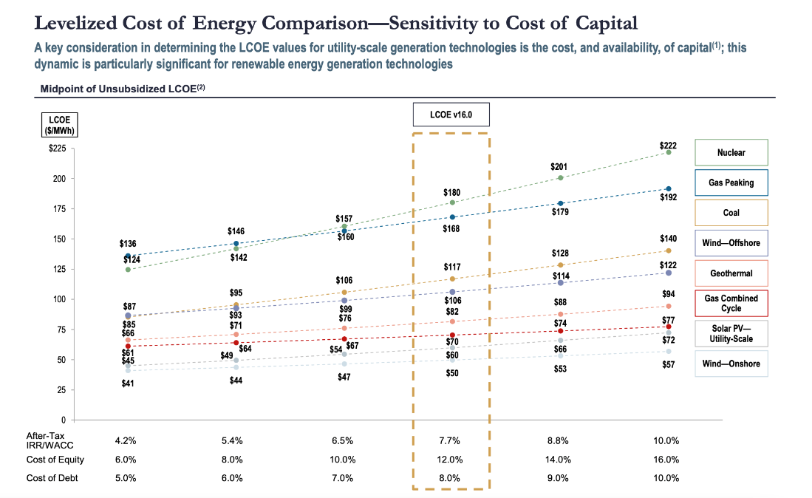
Exhibit 8: Power Generation Technologies LCOE Comparison exhibit
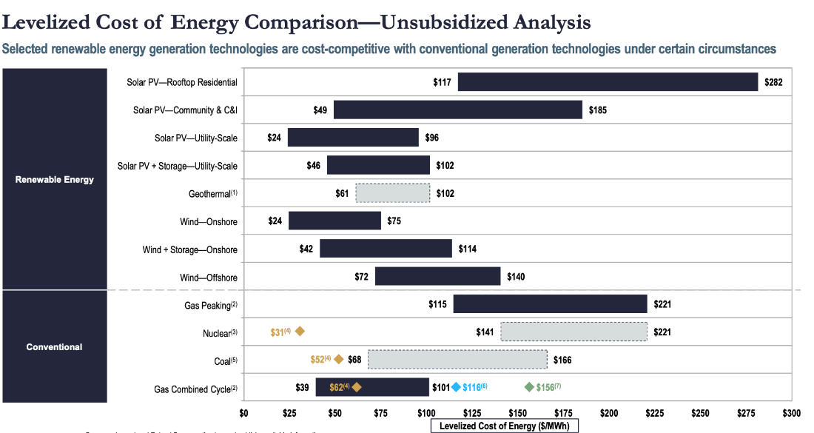
Can go to Lazard’s 2023 report (https://www.lazard.com/research-insights/levelized-cost-of-energyplus/) for further information.

Figure 16: Morro Bay Call Area Extensions
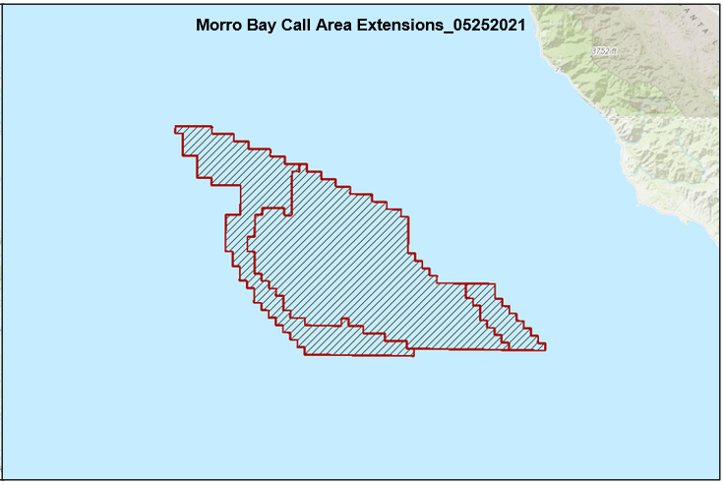
Source: https://caoffshorewind.databasin.org/datasets/03224aeb47394729a064a5d35c097b4a/

https://energy.ec.europa.eu/topics/renewable-energy/offshore-renewable-energy_en#:~:text=EU%20strategy%20on%20offshore%20renewable%20energy,-To%20ensure%20that&text=It%20sets%20targets%20for%20an,GW%2C%20respectively%2C%20by%202050
https://home.treasury.gov/news/press-releases/jy1830
https://calmatters.org/environment/2023/10/california-offshore-wind-central-coast/
https://cei.calpoly.edu/cal-poly-faculty-cyrus-ramezani-phd-and-mahdi-rastad-phd-publish-economic-and-employment-impact
https://www.energy.ca.gov/about/core-responsibility-fact-sheets/developing-renewable-energy
https://www.irena.org/-/media/Files/IRENA/Agency/Publication/2019/Oct/IRENA_Future_of_wind_2019.pdf?rev=c324896ba0f74c99a0cde784f
https://www.nrel.gov/docs/fy24osti/88335.pdf
https://payneinstitute.mines.edu/pc-rising-costs-impact-on-renewable-power-generation/

